**Chapter 4.5 Excel Instructions**

**Create a Discrete Probability Distribution using a PivotTable.**

Open the **MortgageDefaultData.xlsx** File from Chapter 4 folder in the Student Data Files

1. Click Insert Tab on the Ribbon
2. Click PivotTable in the Tables Group
3. When the Create PivotTable dialog box appears
   1. Choose **Select a table or range**
   2. Enter A1:H301 in the Table/Range: box
   3. Select **New Worksheet** as the location for the PivotTable Report
   4. Click Ok

When the PivotTable Fields appear in the new sheet:

1. In the PivotTable Fields Task pane, go to Drag fields between areas below:
   1. Drag the Payments Per Year field to the COLUMNS area
   2. Drag the Customer Number field to the VALUES area
2. Click on Sum of Customer Number in the VALUES area
3. Select Value Field Settings from the list of options
4. When the Value Field Setting s dialog box appears
   1. Under Summarize value field by, select Count
   2. Click Ok

**Calculate the Expected Value for the random variable “Payments Per Year”**

**Way 1:**

1. Make a table with the discrete possibilities and their probabilities

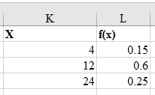

1. In a cell below these cells, type “Expected Value:”
2. Next to this, enter the formula =SUMPRODUCT(K2:K4, L2:L4)

**Way 2:**

1. Type another “Expected Value:”
2. In the cell next to this, enter the formula “=AVERAGE(F2:F301)

**Calculate the Variance and Standard Deviation for the Number of Payments random variable**

**Way 1:**

1. Create a deviations from the mean (Squared) column in the table you created above.

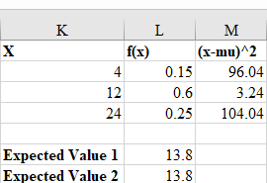

1. In Cell M2 type the formula “=(K2-$L$6)^2” then drag the fill handle down to fill the column
2. Below the Expected Value cells type “Variance 1” into a cell.
3. In the cell next to it enter the formula =SUMPRODUCT(L2:L4,M2:M4)

**Way 2:**

1. Type another “Variance”
2. In the cell next to this, enter the formula “=VAR.P(F2:F301)

**Standard Deviation**

1. In a cell below the Variance cells, type “Standard Deviation”
2. In the cell next to it, type the formula = SQRT(L8)
3. Type another Standard Deviation.
4. In the cell next to it, type the formula “=STDEV.P(F2:F301)